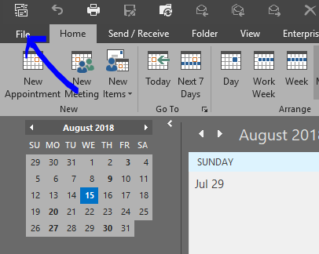
Step 1: In your calendar click on File

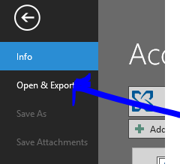
Step 2: Click on
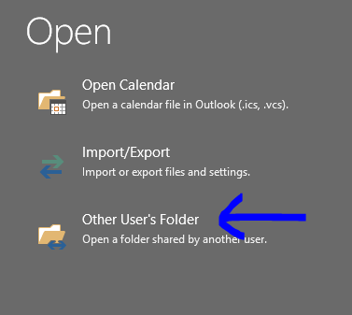
Open & Export

Step 3: Click on
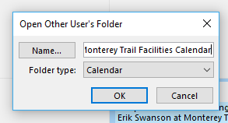
Other User’s Folder

Step 4: Type in
Monterey Trail Facilities Calendar
and hit OK. The calendar should now show in under Shared Calendars in Outlook.

