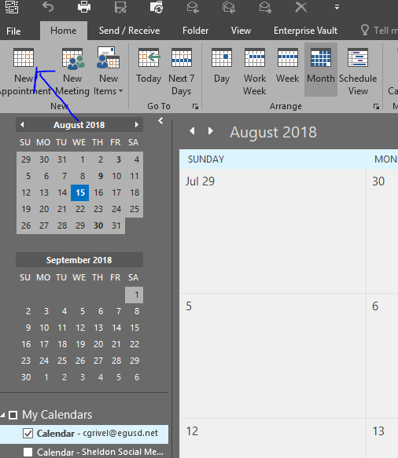
Step 1: Start in your personal calendar and click on New Appointment (Do NOT use New Meeting).

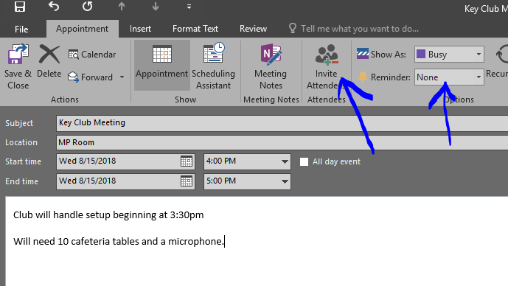
Step 2: Fill in Subject with Name of Activity, Location and Start/End Time/Date. Use the actual start and end time of the event. If you need setup/cleanup time indicate that and any special needs in the description.
Make sure reminder is set to none and then click on Invite Attendees.

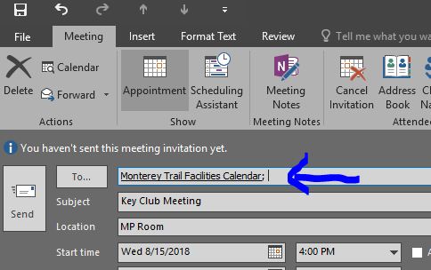
Step 3: Under To… enter Monterey Trail Facilities Calendar and hit Send.
Your request will be emailed to be processed.
You will receive an email response when your request is accepted.

